***Technical University of Cluj-Napoca***

***Automation and Computer Science Faculty***

***Automation and Applied Informatics***

CAD In AUTOMATION

PROJECT

|  |  |
| --- | --- |
| **Student : Ovidiu Moldovan** | **Coordinator:** |
| **Group: 30321** | Assist. Eng. Dan Gota |
|  |  |
| 2017-2018 | |

**Summary**

Contents

Drafting 1 2

Drafting 2 3

OpenGL 3

LISP 4

Explanatory Note 4

**Use the current template to finalize the documentation.**

**Bring a hardcopy of this file and the printed drawing files. For the hardcopy, use the following type of file folder:**

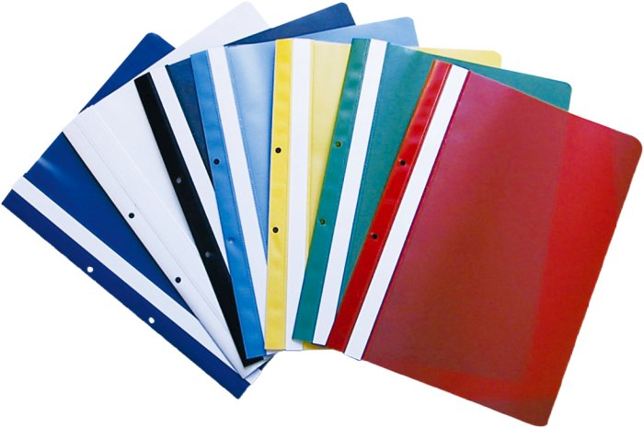

**Bring the zip file with all the resources as presented by the zip template.**

**Deadline: the lab exam.**

Drafting 1

* *Add description of the object and the commands used to finalize the part 1(1/2 pag)*
* *Add pictures of the object.*
* *Add the hyperlink resource into the CAD1 folder.*
* *Print the drawing for the printed version of this document.*

My object is a **joint element**. Some commands I’ve used:

* **PLINE** (w/o different width)**,**
* **CIRCLE, RECTANG,**
* **FILLET** (for rounding the corners)**,**
* **MIRROR** (I’ve drawn half of my object to make sure of its symmetry)**,**
* **DIMLINEAR, DIMRADIUS, DIMANGULAR**
* **TEXT**.

Of course that for the final result I’ve also had to use **MOVE, ROTATE** and **SCALE.**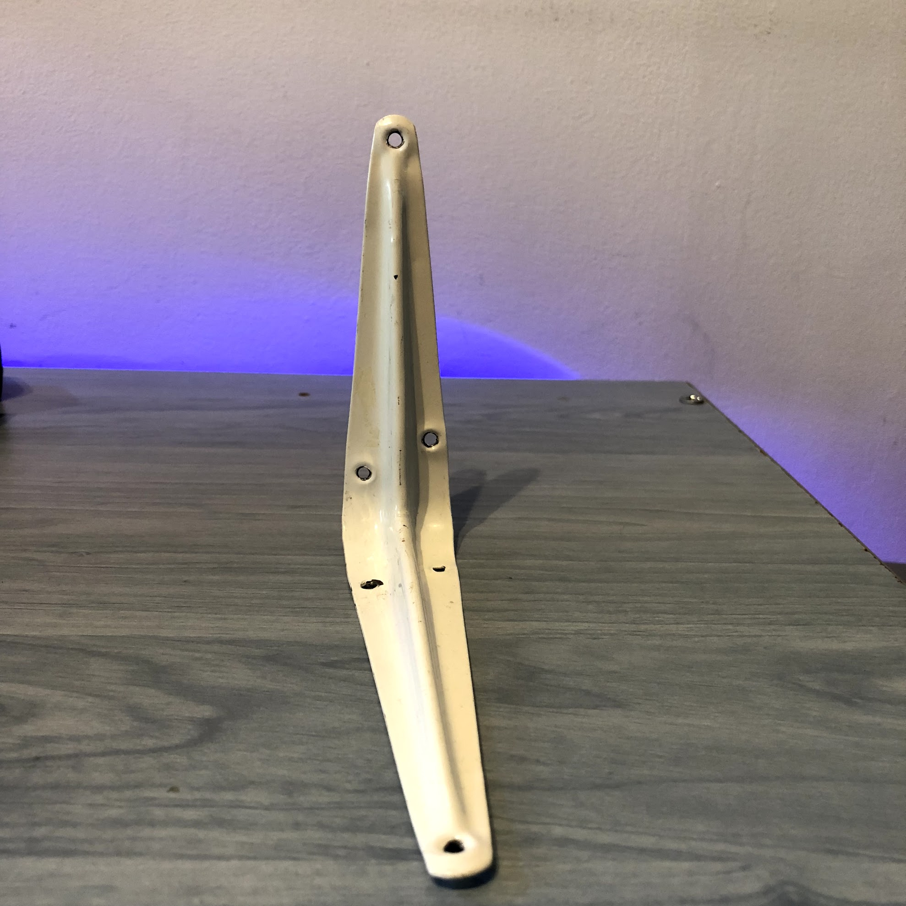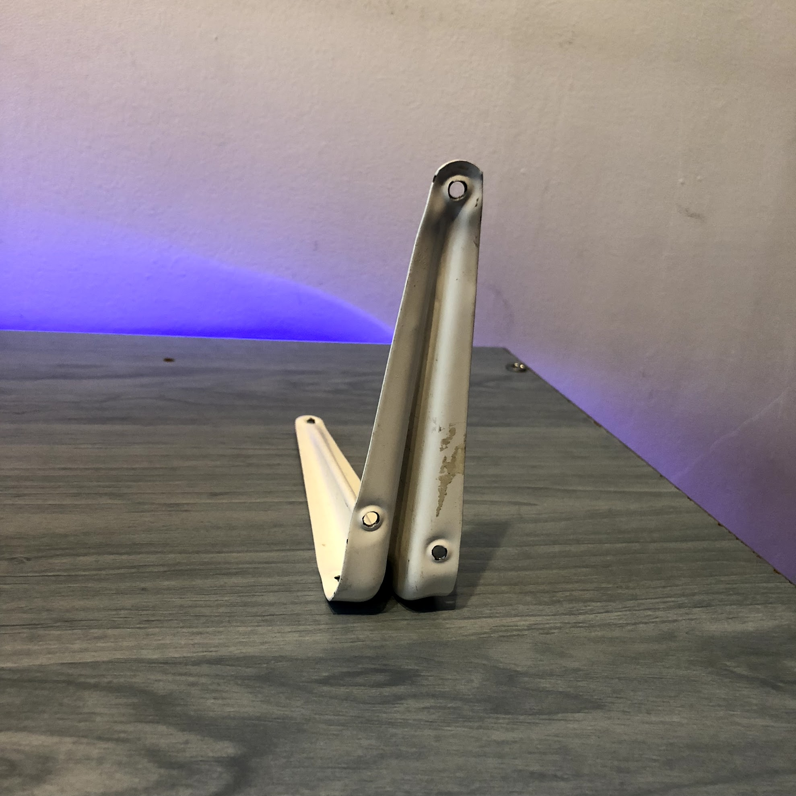

[Click here for the .dwg file.](http:///CAD1/CAD1.dwg)

Drafting 2

* *Add the description of the process and the commands used to finalize the part 2(1 pag)*
* *Add the hyperlink resource into the CAD2 folder.*
* *Add the Bibliography used (hyperlinks or other).*
* *Print the drawing for the printed version of this document.*

OpenGL

* *Add the objective and a short description of the program.*
* *Add the source code with comments.*
* *Add print screens of the output window.*
* *Add the hyperlink resource (the entire project) into the OpenGL folder.*
* *Add the Bibliography used (hyperlinks or other).*

LISP

* *Add description of the program.*
* *Add the source code with comments.*
* *Add the* *hyperlink resource, into the LISP folder.*
* *Add print screens with before and after nthe command created.*
* *Add the Bibliography used (hyperlinks or other).*

Explanatory Note

*Regarding the Bibliography template, see next:*

https://www.ieee.org/documents/ieeecitationref.pdf